2021 Australian Mental Health Prize
Call for nominations

EXAMPLE NEWSLETTER ARTICLE, PHOTO and CAPTION

Nominations are open for the 2021 Australian Mental Health Prize
The Australian Mental Health Prize is awarded annually to an Australian who has made outstanding contributions to either the promotion of mental health, or the prevention or treatment of mental illness.
To be shortlisted or win the Prize is a great honour and it would be a privilege for someone from [name of organisation] to be involved this year. We would like to encourage you to nominate someone you work with or believe has had a positive impact in mental health. Nominations of individuals who were previously nominated, but were not finalists, are welcomed.
UNSW Dean of Medicine & Health, Professor Vlado Perkovic said UNSW Medicine places high importance on mental health research and works with many other mental health institutions and individuals in this area.
“We encourage clinicians, health professionals, community groups and individuals to nominate people whom they feel are making a real difference in the area of mental health research, advocacy or service delivery for the 2021 Australian Mental Health Prize,” he said.
“Mental illness is something that affects our whole community, and the Australian Mental Health Prize is a valuable way to highlight progress being made in this space.”
The finalists for the prestigious prize will be announced in late October. The winner of the Prize will be announced at a gala event in November.
The 2020 winners of the award were Scientia Professor Gordon Parker, founder of the Black Dog Institute and Scientia Professor of Psychiatry, UNSW Sydney, and University of Western Australia Professor Helen Milroy, whose work and research has had a lasting impact on children’s mental health, combining Aboriginal and western knowledge in mental health education.
Nominating someone is a straightforward process. You simply need to submit the CV of the person you are nominating, along with 200 words outlining the work they do and how it is making an impact. Submit your entry at australianmentalhealthprize.org.au
Nominations close on Friday 27 August 2021.
The Prize is supported by UNSW Medicine & Health and the UNSW School of Psychiatry.

Suggested photo and caption to accompany newsletter:
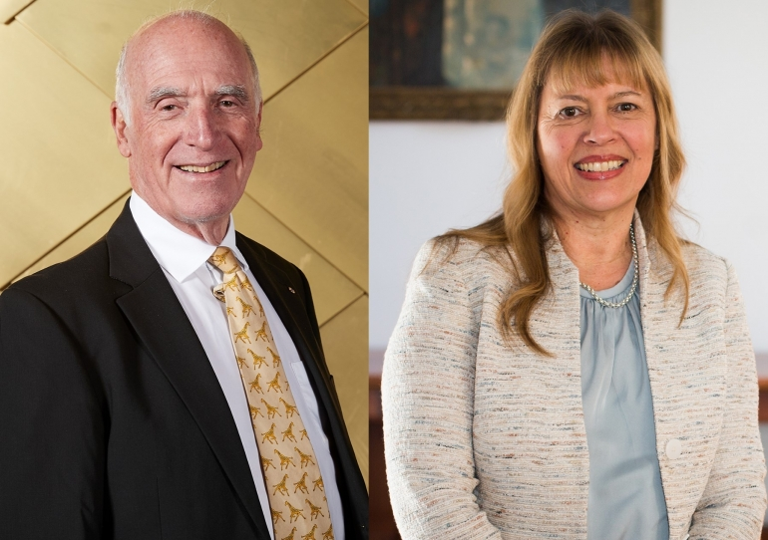
Photo caption: Last year’s Australian Mental Health Prize dual winners Gordon Parker and Helen Milroy.

