Australian Mental Health Prize
Call for nominations 2020

EXAMPLE NEWSLETTER ARTICLE AND PHOTO

Nominations are open for the 2020 Australian Mental Health Prize
The Australian Mental Health Prize is awarded annually to an Australian who has made outstanding contributions to either the promotion of mental health, or the prevention or treatment of mental illness.
To be shortlisted or win the Prize is a great honour and it would be a privilege for someone from [name of organisation] to be involved this year. We would like to encourage you to nominate someone you work with or believe has had a positive impact in mental health. Nominations of individuals who were previously nominated, but were not finalists, are welcomed.
This year’s Prize is more important than ever, as we are experiencing the social and economic impacts of the COVID-19 pandemic, which in turn affect our mental health and wellbeing. Now, more than ever, we must recognise the vital and ground-breaking work that many Australians are contributing to improve mental health.
Ita Buttrose AC OBE, Chair of the Australian Mental Health Prize Advisory Group, will announce the finalists on Monday 26 October. The winner of the Prize will be announced at a gala event in November.
Last year’s dual winners of the award were Joe Williams, a tireless community advocate for suicide prevention, and Christine Morgan, a passionate and dynamic leader in mental health reform who was recently appointed as Suicide Prevention Advisor to the Prime Minister. Mr Williams runs an organisation called The Enemy Within and Ms Morgan is the CEO of the National Mental Health Commission.
Nominating someone is a straightforward process. You simply need to submit the CV of the person you are nominating, along with 200 words outlining the work they do and how it is making an impact. Submit your entry at australianmentalhealthprize.org.au
Nominations close on Sunday 30 August 2020.
The Prize is supported by UNSW’s School of Psychiatry.

Suggested photo and caption to accompany newsletter:
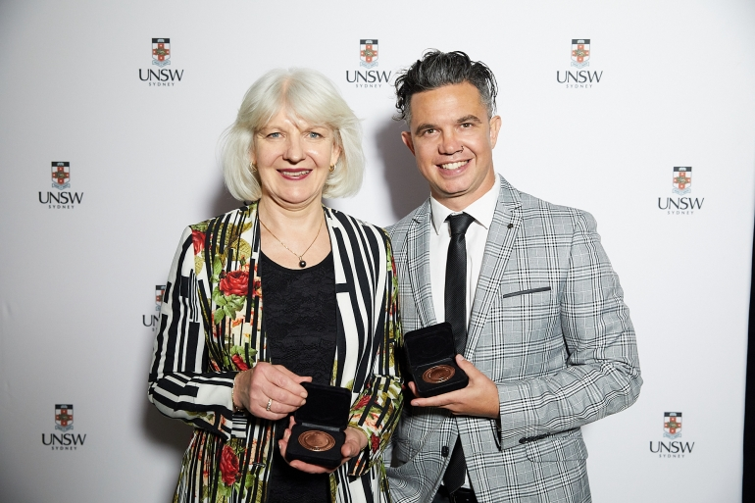
Photo caption: Last year’s Australian Mental Health Prize dual winners Christine Morgan and Joe Williams.

